Smart Vision App

Software Requirements and Design Specifications

Muhammad Qasim: (SP22-BCS-005)
Muhammad Imran: (SP22-BCS-044)

Table of Content
1 Introduction 1
1.1 System Introduction 1
1.2 Background of the System 1
1.3 Objectives of the System 1
1.4 Significance of the System 1
2 Overall Description 2
2.1 Product Perspective 2
2.2 Product Scope 3
2.3 Product Functionality 3
2.4 Users and Characteristics 4
2.5 Operating Environment 5
3 Specific Requirements 6
3.1 Functional Requirements 6
3.2 Behaviour Requirements 6
3.3 External Interface Requirements 7
4 Other Non-functional Requirements 9
4.1 Performance Requirements 9
4.2 Safety and Security Requirements 9
4.3 Software Quality Attributes 9
5 Design Description 11
5.1 Composite Viewpoint 11
5.2 Logical Viewpoint 12
5.3 Information Viewpoint 13
5.4 Interaction Viewpoint 14
5.5 State Dynamics Viewpoint 18
5.6 Algorithm Viewpoint 18

Introduction

1.1 System Introduction
The Smart Vision App is an AI-powered mobile application designed to assist visually impaired individuals by helping them recognize objects, read printed text, and navigate their surroundings independently. The app operates through a voice-controlled interface, enabling users to interact with it hands-free.
Once activated, the application uses AI-based object detection to identify and announce surrounding items and an OCR (Optical Character Recognition) module to read printed or handwritten text aloud. To enhance usability in low-light environments, the app also features an automatic flashlight function. Developed using Flutter for a smooth user interface and Vosk for offline voice recognition, the Smart Vision App delivers a reliable and accessible experience tailored for users with visual impairments.

1.2 Background of the System
Various assistive technologies exist for visually impaired individuals, such as screen readers and smart glasses. However, these solutions are often expensive and depend on continuous internet connectivity. Applications like Seeing AI and Google Lookout offer similar capabilities but typically rely on cloud services, making them less effective in offline or resource-limited settings.
The Smart Vision App offers an affordable, offline alternative by performing AI-based object recognition and OCR entirely on-device. It uses lightweight, efficient models to deliver a fast and intuitive experience. Unlike existing tools, this app is optimized for mobile devices and runs independently of external services, making it suitable for a wide range of users and environments.

1.3 Objectives of the System
- Enable real-time object recognition through a mobile camera

- Provide text-to-speech functionality for printed text via OCR

- Support complete offline voice command navigation

- Detect low-light conditions and activate flashlight automatically

- Ensure accessibility and usability for visually impaired individuals

1.4 Significance of the System
The Smart Vision App aims to improve the quality of life for visually impaired individuals by offering them greater independence in performing everyday tasks. It reduces reliance on human assistance by providing essential features like object recognition and text reading through simple voice commands. Since it works entirely offline and on standard smartphones, the app is practical for use in homes, public places, educational settings, and emergency situations. Its accessibility and affordability make it a valuable contribution to assistive technology, especially in areas with limited resources.

Overall Description

2.1 Product Perspective
The Smart Vision App is a standalone mobile application designed for Android smartphones. It is developed using the Flutter framework and integrates AI capabilities for object detection and text recognition. The app does not rely on cloud-based services or external hardware, ensuring that it runs entirely offline on the user's device. By using pre-trained and lightweight AI models, the app provides real-time assistance to visually impaired individuals without requiring internet connectivity. It makes use of the device's built-in camera, microphone, and flashlight to perform its functions effectively.
Diagram:

- Mobile Device

- Flutter App

- SignUp/Login

- Voice Module

- Object Detection

- OCR

- Flashlight Control

- Authentication

- AI Models (TFLite / ML Kit)

- Firebase

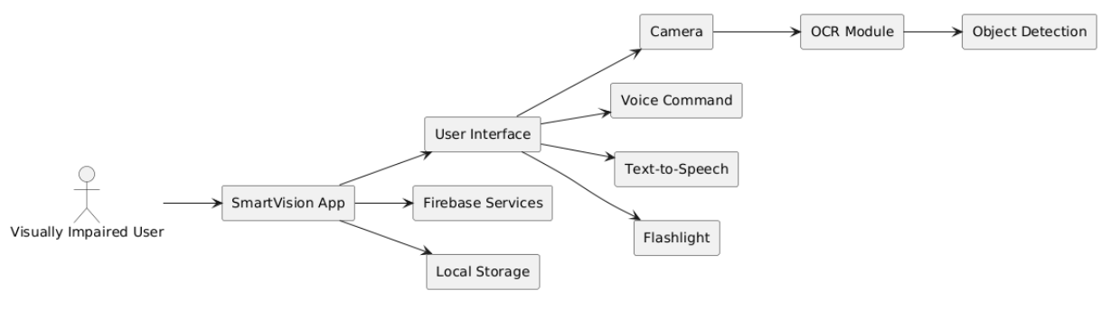
Figure 2.1: System Design

2.2 Product Scope
The primary goal of the Smart Vision App is to provide visually impaired users with tools to interact with their surroundings independently. The app allows users to:
- Recognize and identify nearby objects using the device's camera.
- Read printed text through OCR and convert it to speech.
- Use offline voice commands to control the app’s core features.
- Automatically activate the flashlight in dark environments for improved detection.

2.3 Product Functionality
- Capture images from the mobile device camera

- Perform object detection using AI and announce results through TTS

- Read and extract text from images using OCR

- Provide voice command control to access features without touch input

- Auto-detect low-light conditions and turn on flashlight

- Save user preferences and interaction logs using SQLite and Firebase

- Provide offline functionality for core features like OCR, object detection, and voice command processing

2.3.1 Functional Requirement

• Authentication & User Access

      - The app shall allow users to securely log in and register using email and password via Firebase.

      - The app shall store and manage user profiles with preferences.

    - Camera & Image Capture

    - The app shall use the phone camera to capture images in real time.

    - It shall stream live camera input for object detection.

    - Object Detection Module

    - The system shall detect and identify objects in camera view using TensorFlow Lite.

    - The system shall announce detected objects using audio (Text-to-Speech).

    - OCR (Optical Character Recognition) Module

    - The app shall extract text from printed material using Google ML Kit.

    - The extracted text shall be converted to audio and read aloud to the user.

    - Voice Command Module

    - The system shall listen for user voice commands offline using Vosk.

    - Based on spoken commands, the system shall trigger actions (e.g., “Read Text”, “Detect Object”, “Close the app”).

    - Flashlight Control Module

    - The system shall detect ambient light levels.

    - If low light is detected, the flashlight shall automatically turn on.

    - Offline AI & TTS Integration

    - The app shall work offline using on-device AI models and voice engines.

    - TTS (Text-to-Speech) will provide auditory feedback for all functions.

    - Logging & Storage Module

    - The app shall store user interaction logs and extracted content to Firebase/SQLite.

    - Logs will include timestamps, detected objects, and OCR text.

    - Accessibility & UI

    - The app shall offer a simple, audio-guided interface suitable for blind users.

    - All buttons shall have large touch areas and speak aloud their function.

2.4 Users and Characteristics
- Primary users: Visually impaired individuals

- Limited or no screen interaction

- Rely on voice and audio feedback

- Prefer simple, accessible, and fast UI

- Secondary users: Developers, testers, and caregivers

2.5 Operating Environment
- Android mobile device (minimum Android 10)

- Internet required for Firebase sync

- Offline features (OCR, Object Detection, Voice Commands) must run locally

- Tools: Flutter SDK, TensorFlow Lite, ML Kit, Firebase

Specific Requirements

3.1 Functional Requirements
The system shall provide the following functional requirements:
- FR1: The system shall recognize and announce nearby objects using the device's camera and an object detection model.
- FR2: The system shall extract and read printed text using OCR technology and convert it to speech using TTS.
- FR3: The system shall accept voice commands for tasks such as:
  - “Identify object”
  - “Read text”
  - “Close the app”
- FR4: The system shall turn on the device flashlight automatically in low-light environments.
- FR5: The system shall provide haptic feedback after completing object or text recognition tasks.
- FR6: The system shall operate entirely offline without needing internet access.
- FR7: The system shall display a basic UI allowing manual selection of core features (identify object, read text).
- FR8: The system shall give audible feedback using text-to-speech for all recognized content and system actions.

3.2 Behaviour Requirements
Actors:

- User (Visually Impaired)

Use Cases:

- Manage Profile
- Login and Sign up
- Receive Audio Feedback
- Voice Command
- Read Printed Text
- Detect Objects

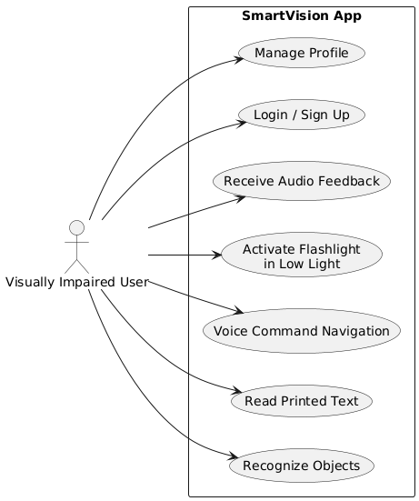
Figure 3.1: Use Case Diagram

3.3 External Interface Requirements

User Interfaces
- Home screen with large icons and text-to-speech guidance

- Settings screen to select voice language/speed

- Voice feedback for every action

Hardware Interfaces
- Rear camera for capturing images

- Light sensor for ambient light detection

- Microphone for voice commands

Software Interfaces
- Android SDK for system access

- Firebase SDK for auth and database

- TFLite models for object detection

- Google ML Kit for OCR

- Vosk for offline speech-to-text

Communications Interfaces
- HTTPs used for Firebase sync

- Data encrypted using Firebase security rules

- Voice commands processed offline (no cloud dependency)

Other Non-functional Requirements

4.1 Performance Requirements
- Object detection response time < 2 seconds

- OCR and speech output within 3 seconds

- Voice command recognition < 1.5 seconds

- Total app size < 80 MB

4.2 Safety and Security Requirements
- Encrypted communication with Firebase

- No sensitive data stored locally without encryption

- Users can delete their data anytime

- Offline fallback if Firebase is unreachable

- App asks for only required permissions

4.3 Software Quality Attributes
4.3.1 Reliability

- Runs without crashes on 90% of tested Android devices

4.3.2 Usability

- UI designed for blind users (audio-first)

- No visual-only interface components

4.3.3 Maintainability

- Modular architecture with separate logic for OCR, AI, Voice, and Auth

- Code documented with inline comments

4.3.4 Portability

- Flutter framework allows future iOS version

- Model foooioiooiiiooooooo99rmats (TFLite) supported across platforms

4.3.5 Adaptability

- Language and TTS engine easily changeable from settings

5 Design Description

Composite Viewpoint

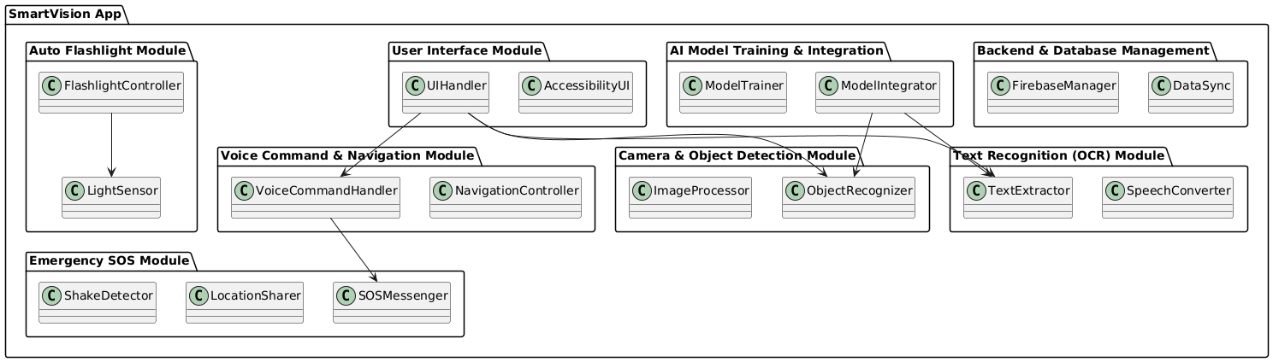
Figure 5.1: Package Diagram of Logical View

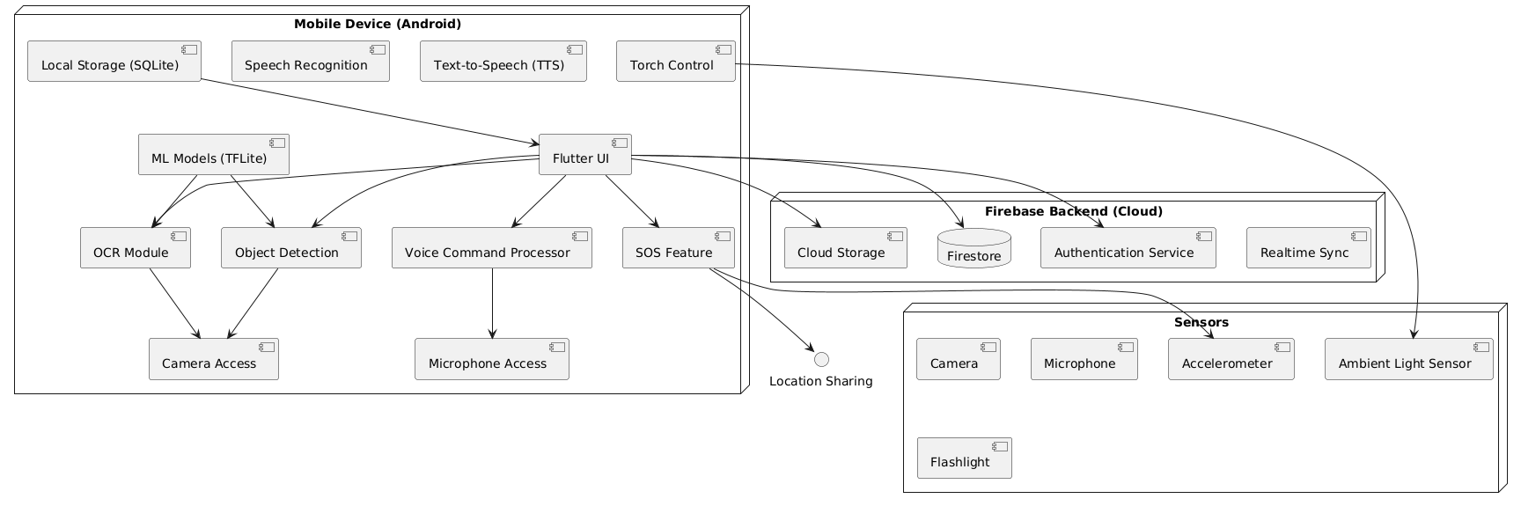
Figure 5.2: Deployment Diagram

Logical Viewpoint

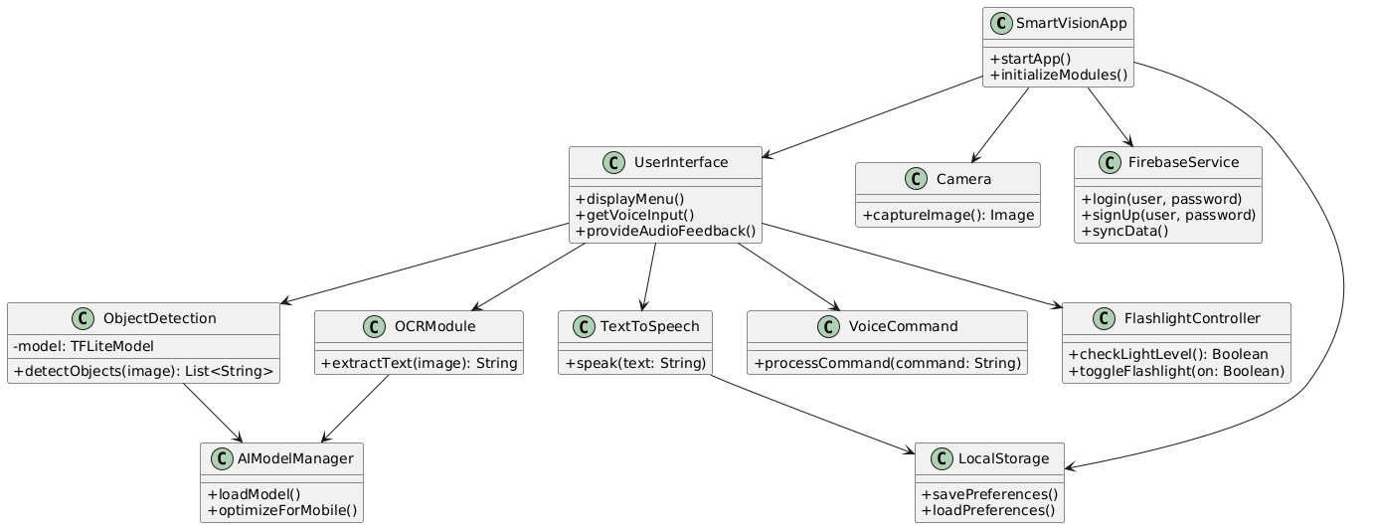
Figure 5.3: Class Diagram of the system

Information Viewpoint

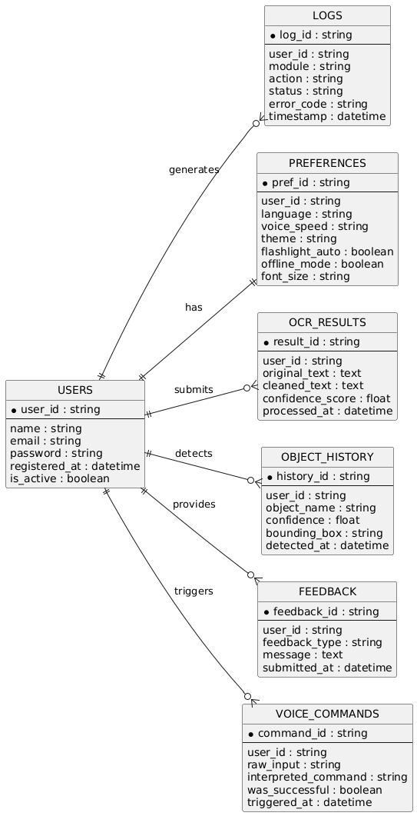
Figure 5.4: ERD Diagram of the System

Interaction Viewpoint

Sequence Diagram for Login/Signup Module

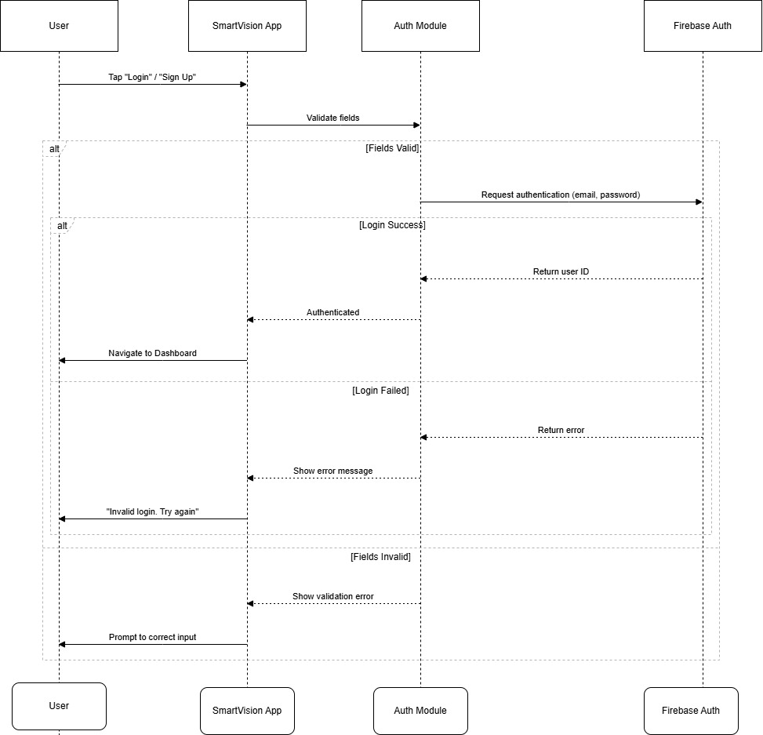
Figure 5.5: Sequence Diagram of Login/Signup Module

Sequence Diagram for Voice Module

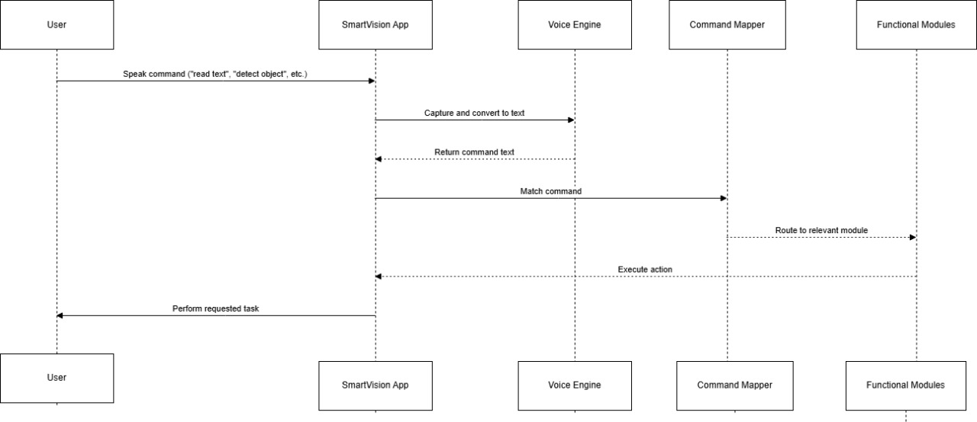
Figure 5.6: Sequence Diagram of Voice Commands Module

Sequence Diagram for Object Detection Module

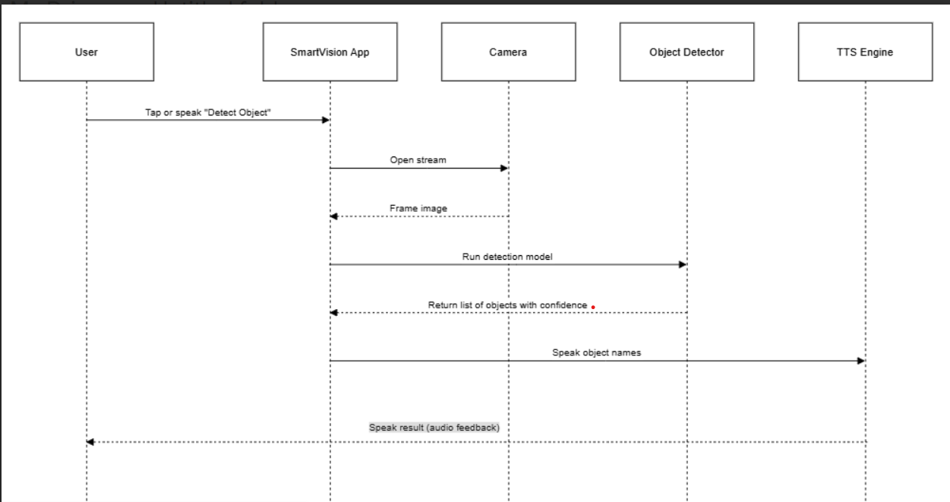
Figure 5.7: Sequence Diagram of Object Detection Module

Sequence Diagram for OCR Module
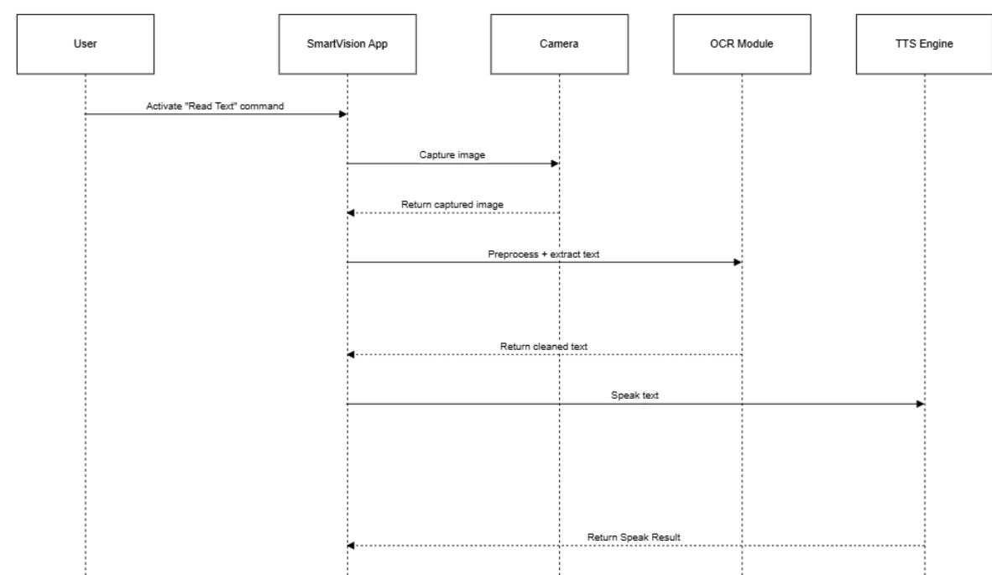
Figure 5.8: Sequence Diagram of OCR Module

Sequence Diagram for Flashlight Module

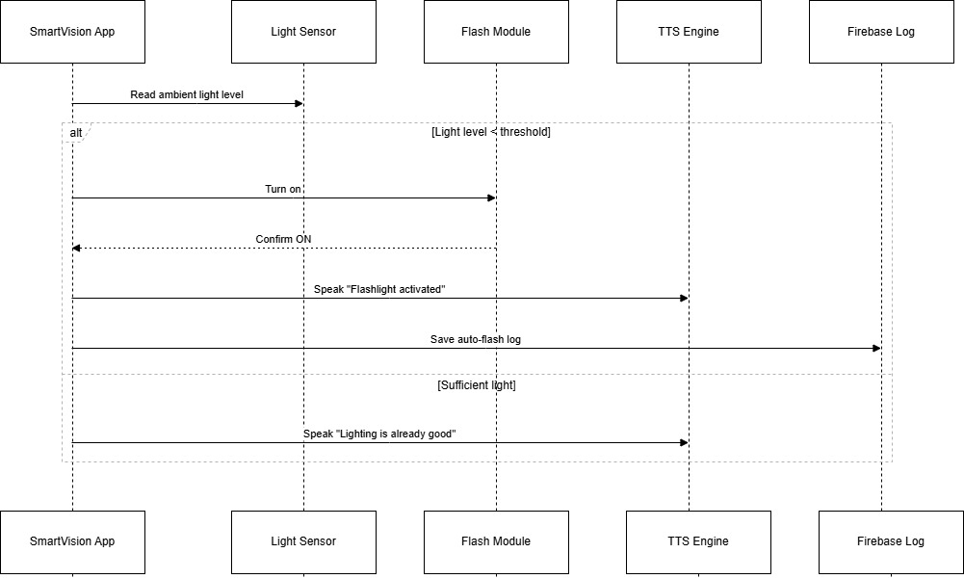
Figure 5.9: Sequence Diagram of Flashlight Module

Sequence Diagram for feedback Module

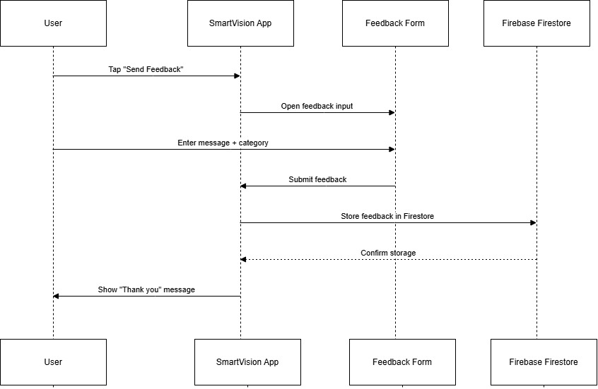
Figure 5.10: Sequence Diagram of Feedback Module

State Dynamics Viewpoint

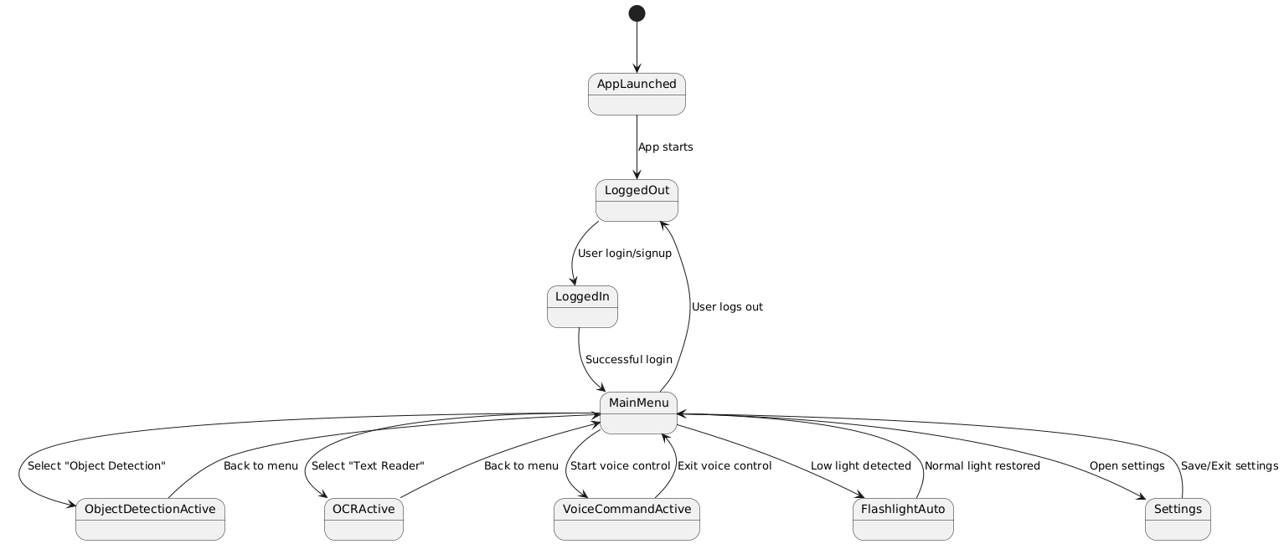
Figure 5.11: State Dynamic View

Algorithm Viewpoint

    - Pseudocode 1: Object Detection Flow

FUNCTION detectObjectsFromCamera():
INIT camera
LOAD TFLite object detection model
WHILE app is running:
CAPTURE frame from camera
IF frame is not empty:
PROCESS frame using TFLite model
DETECT objects and their positions
FOR each detected object:
GET object label (e.g., "bottle", "chair", "phone")
ANNOUNCE label using Text-to-Speech
IF no objects detected:
ANNOUNCE "No object detected"
WAIT for short delay (to avoid flooding)
END WHILE
END FUNCTION

Pseudocode 2: Read Text from Image Flow

FUNCTION startRealTimeTextRecognition():

INIT camera
LOAD on-device OCR engine (e.g., Google ML Kit)

WHILE camera is streaming:
CAPTURE current frame
IF frame is valid:
EXTRACT text using OCR engine
IF text is detected AND text is not repeated:
FORMAT the extracted text
READ text aloud using Text-to-Speech
STORE the last read text to avoid repetition
WAIT for short delay (e.g., 500 milliseconds)

END WHILE

END FUNCTION

Pseudocode 3: Voice Command Handler

FUNCTION voiceCommandHandler():

INITIALIZE voice recognition engine (e.g., Vosk)
LOAD predefined commands:
- "identify object"
- "read text"
- "close the app"

START listening for voice input

WHILE app is running:
WAIT for user to speak
PROCESS audio input
CONVERT speech to text using voice recognition

IF recognizedText == "identify object":
CALL detectObjectsFromCamera()

ELSE IF recognizedText == "read text":
CALL readTextFromImage() OR startRealTimeTextRecognition()

ELSE IF recognizedText == "close the app":
CALL closeApp()

ELSE IF recognizedText == "turn on flashlight":
CALL turnOnFlashlight()

ELSE:
ANNOUNCE "Command not recognized"
END WHILE
END FUNCTION

